# **1. MATLAB - Basic operations**

1. clc
2. clear all
3. Close all
4. rv=[1 2 3 4 5] % row vector
5. cv=rv' % ' - Transpose
6. cv2=[1;2;3;4;5] % column vector
7. lrv=length(rv);
8. srv=size(rv);
9. A=[1 2;3 4]
10. dA=det(A)
11. rA=rank(A)
12. lA=tril(A)
13. uA=triu(A)
14. dA=diag(A)
15. B=[4 5;8 12]
16. C=A+B
17. D1=A*B % * - matrix multiplication
18. D2=A.*B % .* - component-wise multiplication
19. E=inv(A) % inv(A) - inverse of matrix A
20. F1=B'
21. H=A.^3
22. A=[1 2 3 4;5 6 7 8;9 10 11 12;13 14 15 16]
23. size(A)

Slicing a Matrix

1. A(2,:)=[] % removes the elements of row 2
2. size(A)
3. A(:,3)=[] % removes the elements of column 3
4. size(A)
5. sm1=A(2:3,2:3)
6. sm2=A([1 3],[2 1])

Transpose operations

1. x=[1 2 3 4 5]
2. y=[2 2 2 3 3]
3. z1=x*y'
4. z2=x'*y
5. z3=x.*y
6. z4=x.^y
7. z5=x./y

## **Solving system of equations**

A=[4 5;7 8]

b=[7 21]'

x=A\b

set(h,'color','r')

# **PLOTTING OF CURVES AND SURFACES**

Making 3D surface plots, contour plots, and gradient plots in Matlab is slightly more complicated than making simple line graphs, but we will present some examples that, with simple modifications, should enable you to create most of the pictures that you will need.

Matlab provides a variety of functions for displaying data as 2-D or 3-D graphics for 2-D graphics; the command plots vector x1 versus vector y1, vector x2 versus vector y2, etc. on the same graph. Other commands for 2-D graphics are: polar, bar, stairs, loglog, semilogx and semilogy.

For 3-D graphics, the most commonly used commands are:

plot3(x1,y1,z1,’linestyle’, x1,y1,z1,’linestyle’,…..)

contour(x,y,z),mesh(x,y,z),surf(x,y,z)

The first statement is a 3-D analogue of plot() and plots lines and points in 3-D. the second statement produces contour plots of the matrix z using the vectors x and y to control the scaling on the x- and y- axes. For surface or meshplots, you use the third statement where x, y are vectors or matrices and z is a matix. Other commands available for 3-D graphics are: pcolor, image, contour3, fill3, cylinder, and sphere.

## Mathematical form:

* Importance visualizing curves and surfaces

### Draw the curve for the given function f(x)

### Draw the surface for the given function.

## MATLAB Syntax used:

|  |  |
| --- | --- |
| **Command** | **Description** |
| plot(y) | Plots the columns of Y versus the index of each value when Y is a real number. For complex Y, plot(Y) is equivalent to plot(real(Y),imag(Y)) |
| plot3(X1,Y1,Z1) | Displays a three-dimensional plot of a set of data points |
| surf(Z) | Creates a three-dimensional shaded surface from the z components in matrix Z, using x = 1:n and  y = 1:m, where [m,n] = size(Z) |
| ezsurf(fun) | Creates a graph of fun(x,y) using the surf function. fun is plotted over the default domain:  -2π < x < 2π, -2π < y < 2π. |
| y = linspace(a,b,n) | Generates a row vector y of n points linearly spaced between and including a and b. |
| mesh(X,Y,Z) | Draws a wireframe mesh with color determined by Z so color is proportional to surface height |
| [X,Y] = meshgrid(x,y) | Transforms the domain specified by vectors x and y into arrays X and Y, which can be used to evaluate functions of two variables and three-dimensional mesh/surface plots. |
| subplot(m,n,p) | Breaks the figure window into an m-by-n matrix of small axes, selects the pth axes object for the current plot, and returns the axes handle. |
| colormap(map) | Sets the colormap to the matrix map. If any values in map are outside the interval [0 1], you receive the error Colormap must have values in [0, 1]. |
| Prism | Repeats the six colors red, orange, yellow, green, blue, and violet |
| Flag | Consists of the colors red, white, blue, and black. This colormap completely changes color with each index increment |
| hsv | Varies the hue component of the hue-saturation-value color model. The colors begin with red, pass through yellow, green, cyan, blue, magenta, and return to red. |
| shading flat | Controls the color shading of surface and patch graphics objects. |

## 

## **Parametric plotting**

clc

clearall

close all

t = linspace(0, 2*pi,20);

x = 3+2*cos(t);

y = 4+2*sin(t);

plot(x,y,'k-*')

axis equal

xlabel('x(m)')

ylabel('y(m)')

title('graph of (x-1)^2+(y-3)^2=4')

legend('(x-1)^2+(y-3)^2=4')

## OUTPUT

## 

## **Multiple plots in a Figure window (using command hold on)**

clc

clear all

close all

x = linspace(0,1)

plot(x,x.^2,'r*')

hold on

plot(x,sin(x),'g.')

plot(x,exp(x),'m+')

legend('x^2','sin(x)','exp(x)')

OUTPUT

x =

Columns 1 through 9

0 0.0101 0.0202 0.0303 0.0404 0.0505 0.0606 0.0707 0.0808

Columns 10 through 18

0.0909 0.1010 0.1111 0.1212 0.1313 0.1414 0.1515 0.1616 0.1717

Columns 19 through 27

0.1818 0.1919 0.2020 0.2121 0.2222 0.2323 0.2424 0.2525 0.2626

Columns 28 through 36

0.2727 0.2828 0.2929 0.3030 0.3131 0.3232 0.3333 0.3434 0.3535

Columns 37 through 45

0.3636 0.3737 0.3838 0.3939 0.4040 0.4141 0.4242 0.4343 0.4444

Columns 46 through 54

0.4545 0.4646 0.4747 0.4848 0.4949 0.5051 0.5152 0.5253 0.5354

Columns 55 through 63

0.5455 0.5556 0.5657 0.5758 0.5859 0.5960 0.6061 0.6162 0.6263

Columns 64 through 72

0.6364 0.6465 0.6566 0.6667 0.6768 0.6869 0.6970 0.7071 0.7172

Columns 73 through 81

0.7273 0.7374 0.7475 0.7576 0.7677 0.7778 0.7879 0.7980 0.8081

Columns 82 through 90

0.8182 0.8283 0.8384 0.8485 0.8586 0.8687 0.8788 0.8889 0.8990

Columns 91 through 99

0.9091 0.9192 0.9293 0.9394 0.9495 0.9596 0.9697 0.9798 0.9899

Column 100

1.0000

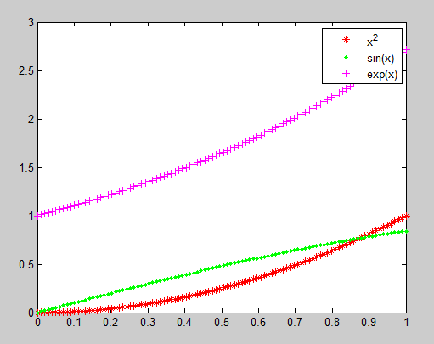

## **Multiple graphs in a Figure window by using subplot**

clc

clear all

close all

x=0:0.1:2*pi;

subplot(2,2,1)

plot(x,sin(x));

subplot(2,2,2)

plot(x,cos(x),'r-*');

subplot(2,2,3)

plot(x,exp(-x),'go')

subplot(2,2,4);

plot(x,sin(3*x),'ms')

## 

## **Graph of a curve through ezplot command**

clc

clear all

symsx % Declaring the parameters as a symbolic object

f=sin(2*x)+cos(3*x)

figure(1)

ezplot(f)

figure(2)

ezplot(f,[0,3])

**OUTPUT**

f =

cos(3*x) + sin(2*x)

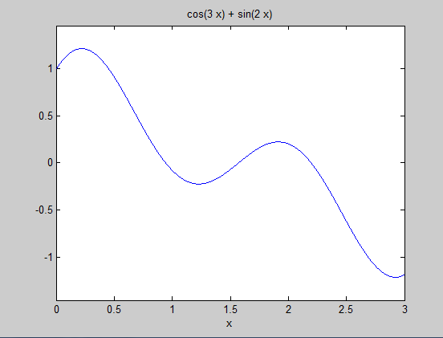

## **Graph of a curve and its tangent line in the neighbourhood D of a point.**

symsx

%y=input('enter the function f in terms of x:')% Example, Try the function y=x^2-2*x;

y=x^2-2*x;

%x1 = input('Enter x value at which tangent : '); % Example, Try the point x1 = 2

x1=2;

D=[x1-2 x1+2]% Region about x1 (or Neighbourhood of x1)

ezplot(y,D) % graph of the curve in D

hold on

%Equation of the tangent line passing through x1.

yd = diff(y,x); % Differentiation in MATLAB

slope = subs(yd,x,x1); % Finding the slope at x1

y1 = subs(y,x,x1); % Finding the value of the function at the given point

plot(x1,y1,'ko') % plot the point

Tgt_line = slope*(x-x1)+y1 % Tangent Line Equation at the given point

h = ezplot(Tgt_line,D); % Plotting the Tangent Line

set(h,'color','r')

## OUTPUT

## 

1. Find the equation of tangent to the curve  at (1,2).

syms x

y= 2*sqrt(x);

x1=1;

D=[x1-2 x1+2]

D =

-1 3

ezplot(y,D)

hold on

yd = diff(y,x);

slope = subs(yd,x,x1);

y1 = subs(y,x,x1);

plot(x1,y1,'ko')

Tgt_line = slope*(x-x1)+y1

Tgt_line = x + 1

h = ezplot(Tgt_line,D);

set(h,'color','r')

OUTPUT

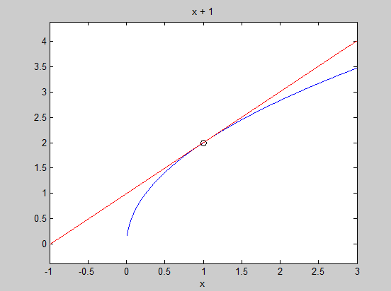

1. Find the equation of tangent to the curve  at (-2,-8).

syms x

y=x^3;

x1=-2;

D=[x1-2 x1+2]

D =

-4 0

ezplot(y,D)

hold on

yd = diff(y,x);

slope = subs(yd,x,x1);

y1 = subs(y,x,x1);

plot(x1,y1,'ko')

Tgt_line = slope*(x-x1)+y1

Tgt_line =

12*x + 16

h = ezplot(Tgt_line,D);

set(h,'color','r')

OUTPUT

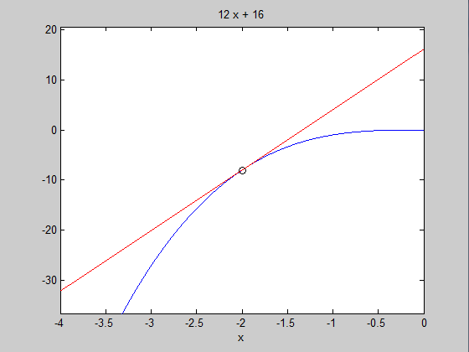

## **extrema of a single variable function.**

syms x real

f= input('Enter the function f(x):');

fx= diff(f,x)

c = solve(fx)

cmin = min(double(c));

cmax = max(double(c));

ezplot(f,[cmin-2,cmax+2])

hold on

fxx= diff(fx,x)

for i = 1:1:size(c)

    T1 = subs(fxx, x ,c(i) );

    T3= subs(f, x, c(i));

 if (double(T1)==0)

    sprintf('The point x is %d inflexion point',double (c(i)))

    else

         if (double(T1) < 0)

    sprintf('The maximum point x is %d', double(c(i)))

    sprintf('The value of the function is %d', double (T3))

         else

    sprintf('The minimum point x is %d', double(c(i)))

                sprintf('The value of the function is %d', double (T3))

         end

 end

plot(double(c(i)), double(T3), 'r*', 'markersize', 15);

end

pause

h=ezplot(fx,[cmin-2,cmax+2])

set(h,'color','r')

hold on

pause

e=ezplot(fxx,[cmin-4,cmax+4])

set(e,'color','g')

hold off

**OUTPUT**

**Enter the function f(x):x^4**

**fx =**

**4*x^3**

**c =**

**0**

**0**

**0**

**fxx =**

**12*x^2**

**ans =**

**The point x is 0 inflexion point**

**ans =**

**The point x is 0 inflexion point**

**ans =**

**The point x is 0 inflexion point**

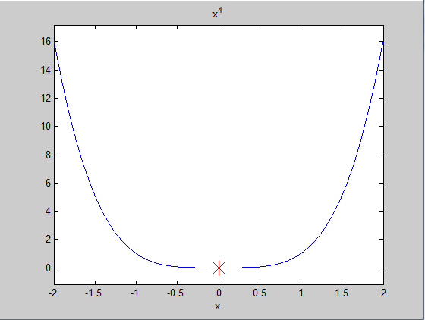

**Practice Problems:**

1. An open-top box is to be made by cutting small congruent squares from the comers of a 12-in.-by-12-in. sheet of tin and bending up the sides. How large should the squares cut from the corners be to make the box hold as much as possible?

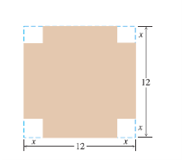

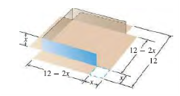

.

/var/folders/7h/nbsqj6k5671dmkjvdyh5xws40000gn/T/com.microsoft.Word/Content.MSO/96DAEAA.tmp

Enter the function f(x):4*x^3-48*x^2+144*x

fx =12*x^2 - 96*x + 144

c =

2

6

fxx =24*x - 96

ans =The maximum point x is 2

ans =The value of the function is 128

ans =The minimum point x is 6

ans =The value of the function is 0

h = 179.0059

e =180.0059

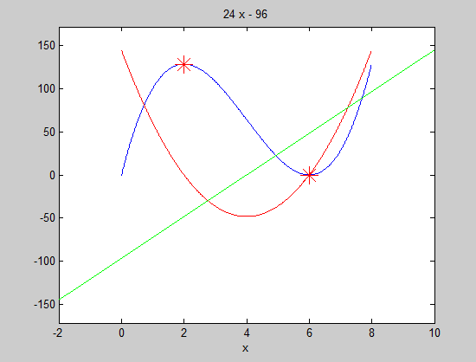

1. A rectangle is to be inscribed in a semicircle of radius 2. What is the largest area the rectangle can have, and whatare its dimensions?

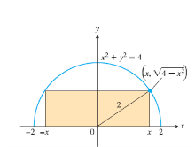

Length :2x, Height: /var/folders/7h/nbsqj6k5671dmkjvdyh5xws40000gn/T/com.microsoft.Word/Content.MSO/9EB02196.tmp Area: 2x/var/folders/7h/nbsqj6k5671dmkjvdyh5xws40000gn/T/com.microsoft.Word/Content.MSO/E1417A14.tmp.  A(x)= 2x/var/folders/7h/nbsqj6k5671dmkjvdyh5xws40000gn/T/com.microsoft.Word/Content.MSO/BC922D42.tmp.

## OUTPUT

## Enter the function f(x): 2*x*sqrt(4-x^2)

## fx =2*(4 - x^2)^(1/2) - (2*x^2)/(4 - x^2)^(1/2)

## c = 2^(1/2)

## -2^(1/2)

## fxx =- (2*x^3)/(4 - x^2)^(3/2) - (6*x)/(4 - x^2)^(1/2)

## ans =The maximum point x is 1.414214e+00

## ans =The value of the function is 4

## ans =The minimum point x is -1.414214e+00

## ans =The value of the function is -4

## h = 179.0071

## e = 180.0071

## 